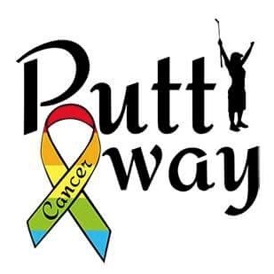

Impact Chronicles

horizontal line

# Welcome to P.A.C. Impact Chronicles

Putt Away Cancer Foundation Quarterly Newsletter

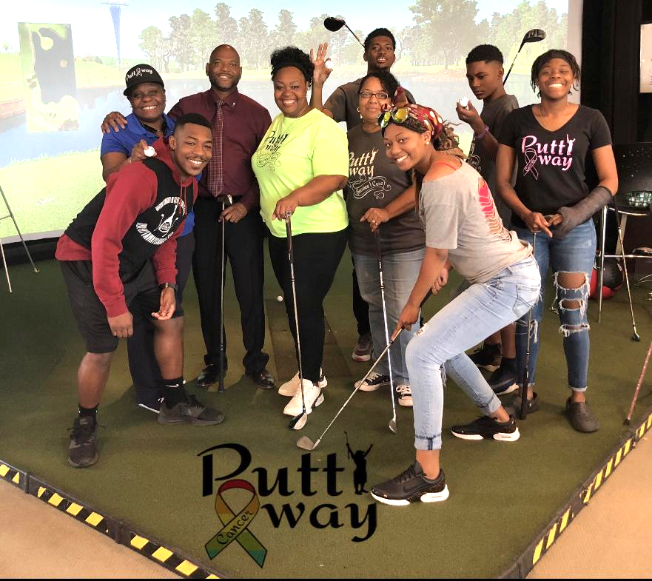

The Putt Away Cancer Foundation would like to welcome to our 1st edition of the P.A.C. Impact Chronicles. The purpose of our newsletter is to chronicle everything happening with our beloved Foundation on a quarterly basis. The Newsletter will demonstrate how we are measuring up to our Mission to inspire HOPE, to encourage FAITH, and to promote LIFE to make an impact on the cancer community.

In our newsletter, you may find helpful information regarding the latest trends, treatments, or testimonies from other cancer warriors and physicians. There have been many great developments surrounding Cancer treatments that may be beneficial to someone. Also, hearing how someone survived their battle can also be that extra boost of HOPE you may need to make it through. So, stay tuned for the HOPE Chronicles section of the newsletter.

horizontal line

**TOP STORIES**

## What are HOPE Awards?

The purpose of The Putt Away Cancer Foundation is to help breach a financial gap cancer warriors and their families endure. The Crystal Branner Circle of HOPE Award is a financial donation for Cancer Warriors to use at their own discretion. Any Texas resident battling cancer is eligible to apply. The Linda C. Bryant HOPE Scholarship is a onetime book scholarship for Texas high school seniors going to college or current college students that graduated from a Texas High School. Fundraiser events and donations provide for the donations that are granted. We are a family organization and host family events, because we understand that Cancer is bigger than one person. Visit our website: www.puttawaycancer.com for more information. 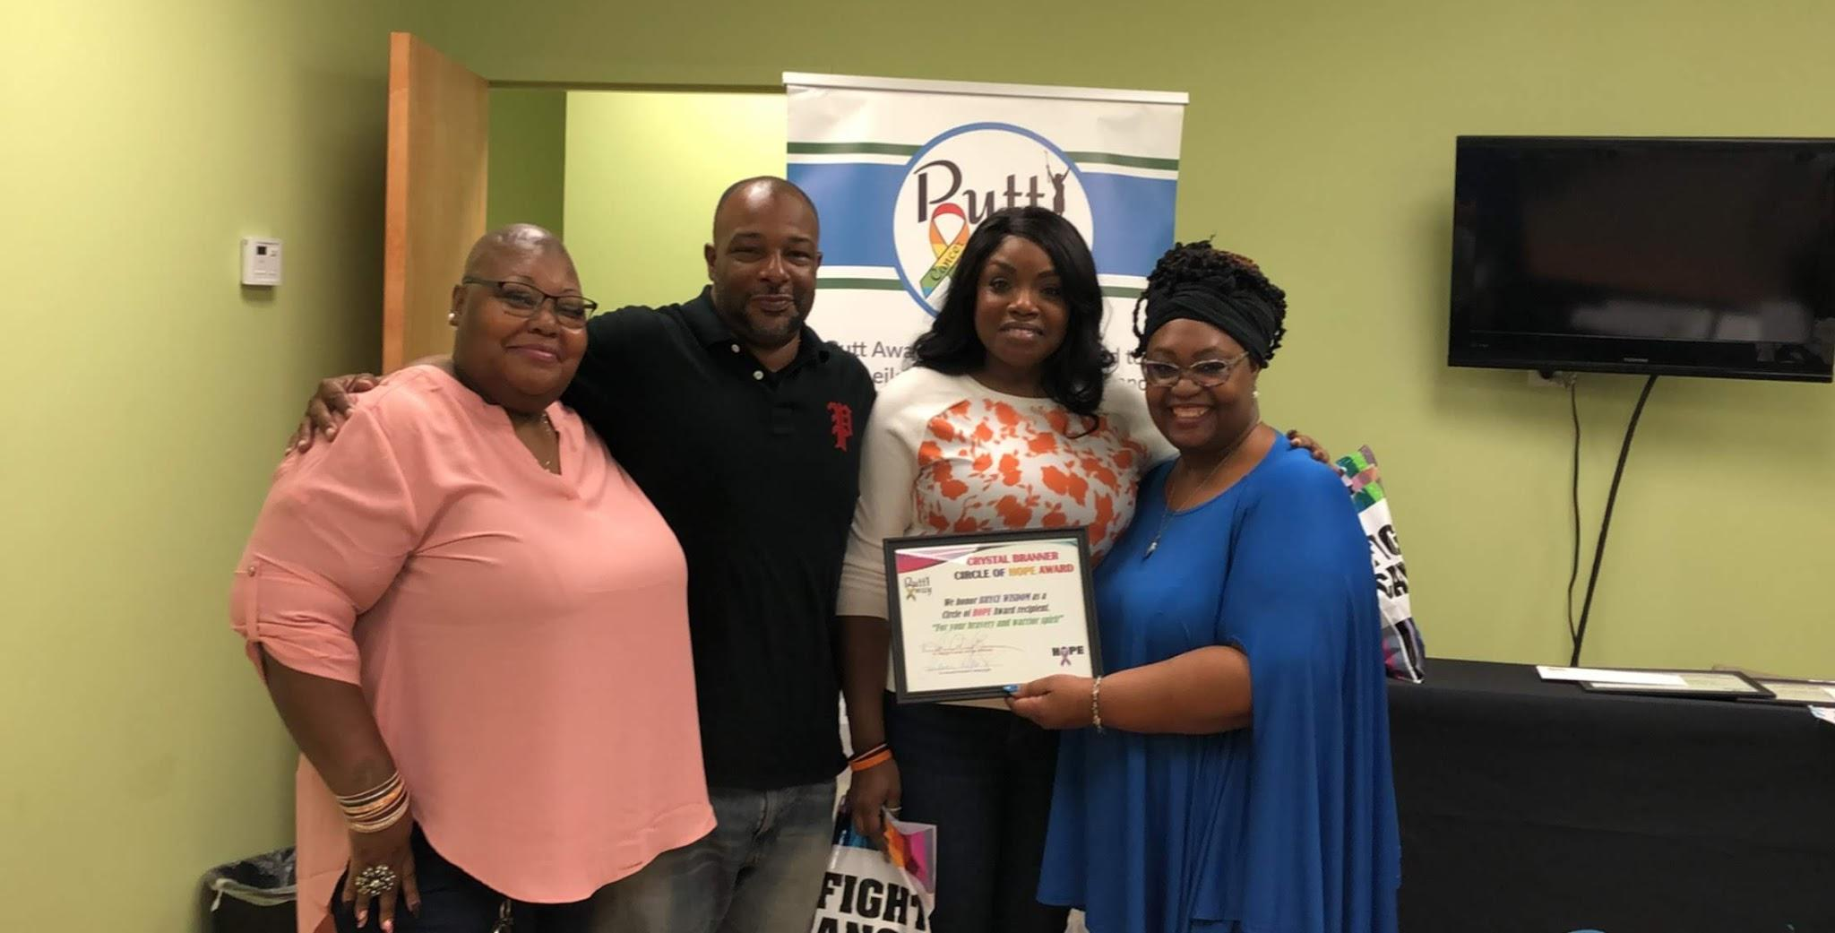

[Visit here to learn about our HOPE Awards](https://puttawaycancer.com/about-us/award/)

## HOPE Chronicles

Have you heard of the science of epigenetics? It proposes that your genes are greatly influenced by your disposition, good or bad. Feeding your soul with purpose and HOPE can heal the emptiness, the fear, and the spirit of defeat experienced by those suffering cancers. In a dream, our Founder was given the vision of Putt Away Cancer. The premises are simply to inspire HOPE through giving. Why? Because cancer warriors battle confusion and tough decisions of how to pay for things needed outside of medical bills because insurance doesn’t always cover everything. And no one can really prepare for the possibility of a cancer diagnosis or any other catastrophic illness. So, The Putt Away Cancer Foundation takes a community approach to bring awareness to the many spiritual and emotional struggles Cancer Warriors battle, which is not just the medical diagnosis itself. While supporting research is necessary, the Putt Away Cancer Foundation is about the individual warriors and not about research. All our fundraisers go to those that are being impacted by this terrible disease. We believe in the science of epigenetics and we will combat despair with HOPE and we will do it by bringing unity into the cancer community.

“Hope is the thing with feathers that perches in the soul, and sings the tune without the words, and never stops at all.” —Emily Dickinson

|  |
| --- |
| [**LEARN HOW YOU CAN HELP ON OUR WEBSITE**](https://www.puttawaycancer.com) |

## Thank you to our Donors

In 2019, our Foundation did not host any fundraising events. However, through word of mouth we gifted 7 Crystal Branner Circle of HOPE Awards. We would like to thank **San Antonio Minority Golf Association** for donating $6000, **John and Tara Addie** for their donation of $1800, and **Keith Jones of JT Innovations & Properties** for donating $1,000. 

We would also like to thank **JC Cares Foundation** for your generous donation of $2500 which allowed us to fund our Inaugural Linda C. Bryant HOPE Scholarship. This scholarship is for graduating Texas High School Seniors or College students that graduated from a Texas High School whose life has been significantly impacted by cancer. In August 2019, we gave away our first scholarship to Wagner High School graduate, Yhan Jimenz , who is the first to attend college in his family.

## Call to Action

Join us in giving and MAKE A DONATION TODAY! You can become a HOPE Warrior and set up recurring Tax-Deductible donations of $5, $10, $20, or whatever is placed upon your heart. This will support The Putt Away Cancer Foundation to continue our mission to make an impact on the cancer community. Together we can Putt Away Cancer.

[Make a Donation to our Foundation](https://puttawaycancer.com/how-you-can-help/)

horizontal line

The Putt Away Cancer Foundation

San Antonio, TX 78244